Business Analysis 2B

Individual Practical Assignment

Business Analysis Investigation – FreshBite Restaurant

Part 1:
Main Business Problem:
The main business problem is that FreshBite uses different methods to receive customer orders, such as waiters, phone calls and WhatsApp. This causes problems such as incorrect orders, incomplete information sent to the kitchen, long customer waiting times and poor order tracking.
Management also has difficulty tracking sales and identifying popular menu items.
Business Objectives:
The business objective is to improve the ordering and order-management process so that customer orders are captured accurately, complete information reaches the kitchen, customers can receive updates about their orders, waiting times can be reduced, and management can obtain useful sales and menu-item information.
Stakeholders:
Stakeholder | What they need | Problem experienced
Waiters | Easy way to record customer orders correctly | Orders can be recorded incorrectly
Kitchen Staff | Complete and clear order information | They sometimes receive incomplete information
Customers | Correct orders and information about order status | Customers wait too long and do not always know their status
Restaurant Owner | Accurate sales information and better control of orders | Difficult tracking sales and popular menu items

Part 2:
Question and purpose of each question:
1. Can you describe the current process from the moment a customer places an order until the order is delivered to the customer?
2. What problems usually happen when an order is recorded?
3. What information must be captured for every customer order before the kitchen can start preparing it?
4. How do waiters and kitchen staff currently communicate changes, special requests or corrections to an order?
5. How do customers currently find out whether their order has been received, is being prepared or is ready?
6. What situations or exceptions commonly cause an order to be delayed, changed or recorded incorrectly?
7. What sales or menu-item information does management need to see when monitoring the restaurant?
8. If a digital ordering and order-management solution were introduced, what features would make the current process easier or more reliable?

Part 3:
ID | Requirement | Type | Type
FR1 | The system shall allow staff to capture and record customer orders digitally, including the ordered menu items and relevant order information. | Functional | This reduces errors caused by manually recording orders and creates a consistent order record.
FR2 | The system shall send complete order information to the kitchen after an order has been confirmed. | Functional | Kitchen staff need complete information so that orders can be prepared correctly.
FR3 | The system shall allow customers or staff to view the status of an order. | Functional | This gives customers visibility of their order and reduces uncertainty about waiting time.
FR4 | The system shall record sales and menu-item information so that management can review sales and identify popular menu items. | Functional | Management currently has difficulty tracking sales and popular items.
NFR1 | The ordering process should be easy for staff and customers to understand and use. | Non-functional | A simple process supports adoption and reduces the chance of additional ordering errors.
NFR2 | The system should protect stored order and sales information from unauthorised access. | Non-functional | Only appropriate users should be able to access business and order information.
BR1 | An order must contain the required customer/order information and selected menu items before it is sent to the kitchen. | Business Rule | This prevents incomplete orders from reaching the kitchen.
BR2 | An order should have a recorded status that changes as it moves through the ordering process, such as received, preparing and ready | Business Rule | A consistent status process allows staff and customers to understand the current stage of an order.

Part 4:
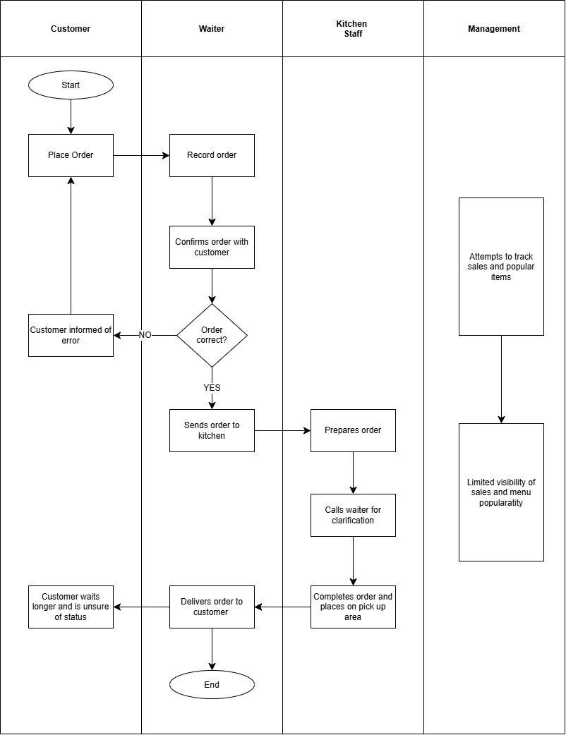

Part 5:
1)SIPOC Analysis:
SIPOC was selected because it provides a high-level view of the FreshBite ordering process by identifying the suppliers, inputs, main process activities, outputs and customers. It helps establish the boundaries of the process before designing a solution.
S  (Suppliers) | I  (Inputs) | P  (Process) | O  (Outputs) | C  (Customers)
- Food suppliers  - Beverages  Suppliers  - Staff  - Customers  - Technology provider | - Raw material  - Menu items  - Customer orders  - Staff Resources  - Equipment  - POS / digital system | Prepare food  Close order  Deliver order  Receive order | - Prepared meals  - Customer satisfaction  - Sales data  - Order records  - Reports | - Restaurant customers  - Management  - Kitchen staff  - Waiters  - Suppliers

What SIPOC helped to understand: The technique showed that FreshBite has several order-entry channels feeding into a process that eventually needs to provide accurate information to the kitchen and the customer. It also highlighted where inputs can become incomplete or inaccurate.

